|  |  |  |  |
| --- | --- | --- | --- |
|  | Bansilal Ramnath Agarwal Charitable Trust's  Vishwakarma Institute of Information Technology  **Department of**  **Artificial Intelligence and Data Science** | | |
| Name: Siddhesh Dilip Khairnar | | | |
| Class: SY | Division: B | | Roll No: 272028 |
| Semester: III | | Academic Year: 2022-2023 | |
| Subject Name & Code: Database Management System: ADUA21204 | | | |
| Title of Assignment: PL/SQL Stored Procedure and Stored Function: Write a PL/SQL procedure to find the number of students ranging from 100-80%, 79-70% ,69-60%, 59-50 & below 49% in each course from the Student_course table given by the procedure as parameter. Student_course (Roll_no, Course, Couse_code, Semester, Total_ Marks, Percentage). | | | |

**Assignment No.- 05**

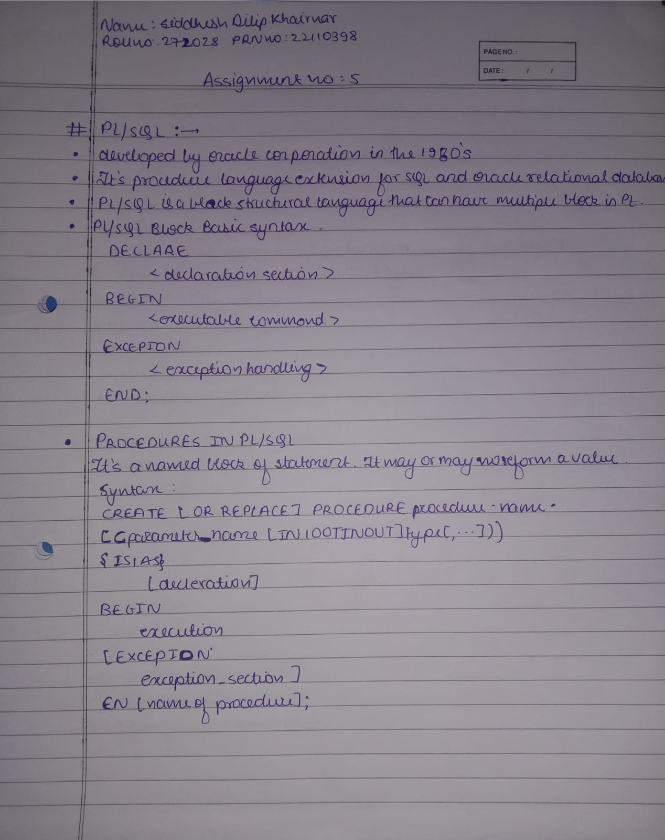

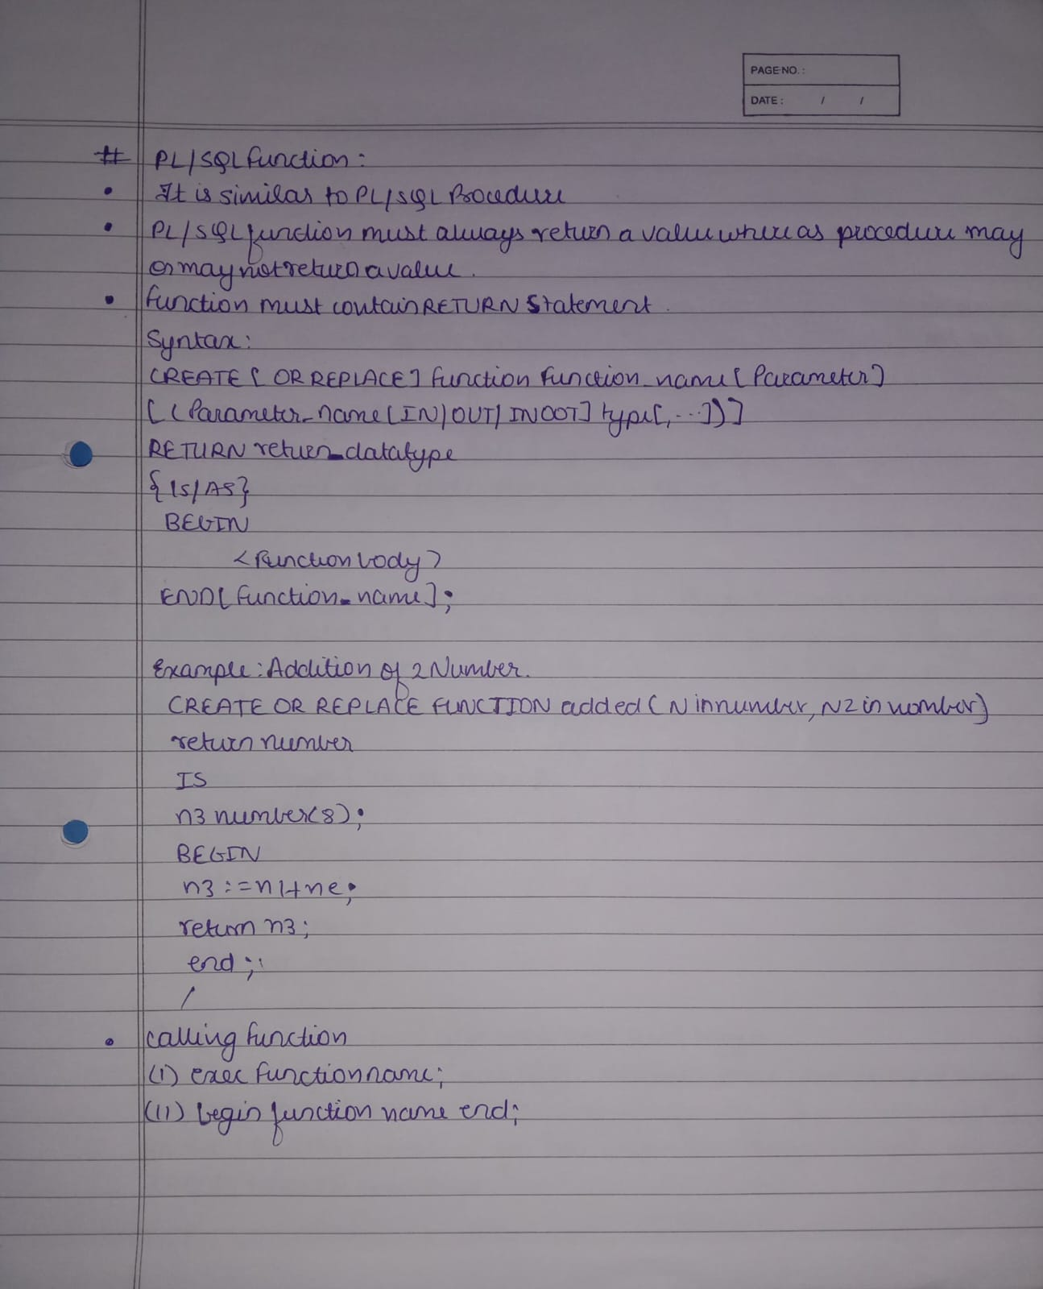

**Implementation:**

**Table used for the following operations**

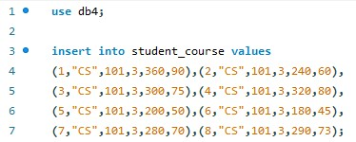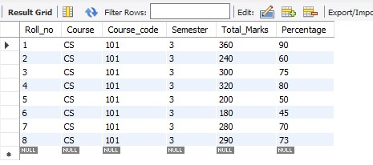

**Stored Procedure**

